Software Testing

Table of Contents

1 INTRODUCTION ................................................................
2 Testing Principals.................................................................
3 Types of Software Testing .............................................................
4 Software Testing Methods..............................................
5 Software Testing Levels..............................................................
6 SDLC...................................................................
7 STLC....................................................................................
8 Software Testing Documentation...............................................
9 Test Plan...................................................................
10 Test Scenario...................................................................
11 Test Case...................................................................
12 Traceability Matrix...................................................................
13 Alpha and Beta Testing...................................................................
14 Bug Life Cycle...................................................................
15 Verification and Validation----------------------------------

- INTRODUCTION

Software testing can be defined as the action for checking if the tangible result or output of product matches with the projected or expected output (of your client), and testing also ensures that the product is free from any bug or defect. Testing of software involves the implementation of a module or part of a system of a product to evaluate all or some of its properties. Through testing, testers can identify errors, gaps in the requirement, or missing elements in a projector system (that has been developed). Testing can be done both manually or with the help of automated tools available in the market. Software testing can be broken into two main testing types - White box testing and Black Box Testing.

Why is Software Testing Important?
Software testing plays a significant role in software or system; bugs can be expensive and can lead to a dangerous situation. Bugs in software or application can likely lead to loss of monetary value, jobs, or even a human loss. Here is some real-life examples of how untested software can become hazardous:
Who Does Testing?
This question's answer is depending on the process and its connected project-stakeholders. In the information technology industry, big companies have team members responsible for evaluating the project or software based on the requirements during the test phase. Moreover, some bugs can get detected if proper testing is done in the development stage of a software or application. So, people who can do testing are:
- Software Testers
- Project Developer
- Project Lead
- Team Manager
- End Users
2 Testing Principals

Testing of software is exceptionally imaginative and an intellectual task for testers to perform. The testing of software or applications pursues some principles that are mentioned in this chapter. These principles also play a significant role for a software tester to test the project. These principles are:
- Software testing can help detect bugs: Testing any software or project can reveal a few or some defects that may or may not be detected by developers. However, testing of software alone cannot confirm that your developed project or software is error-free. Hence, it's essential to devise test cases and find out as many defects as possible.
- Testing with effectiveness is impossible: Until your project or application under test has a straightforward structure having limited input, it won't be likely or achievable to check and test all feasible sets of data, modules, and scenarios.
- Early testing: The earlier you will begin to test your project or software, the better you will utilize your existing time.
- Defect in clustering: At the time of testing, you can observe that majority of the defects or bugs reported are because of a small number of modules inside your software or system.
- Software testing is context-dependent: Various methods, procedures, and kinds of testing are there, which defines the type and characteristics of the application. For example, an application related to a health device needs more testing and doctor-based feedback than a game or small software.
- Errorfree or Bug-free software is a myth: Just because when a tester tested an application and didn't detect any defects in that project doesn't indicate or imply that your software is ready for shipping.

3 Types of Software Testing

Manual Testing:

In manual testing, software testing is done manually without the use of automated tools or applications available in the market. In this form of testing, the software tester tests or checks for bugs like the end-user and checks the project for identifying any abnormal behaviour or bugs in it. Various diverse phases are there for testing a project manually. These are:
- unit-testing
- integration testing
- system testing and
- user acceptance testing

Automation Testing:
In automation testing (also termed as Software Test Automation), the software tester must write different scripts and apply other 3rd party software to test the software. Automation testing involves the manual process done automatically. It is implemented for re-running the test situations and states done manually and at the same time at a fast pace and repeatedly performed to check whether any bug or error is left behind or not from the previous test. This type of testing also deals with checking load, performance stats, CPU and memory usage, and activities. Automation testing is more advantageous than manual testing as it saves the tester's time and money.

Automated Test Tools:
Automated testing needs the support of various languages such as VBScript along with automated applications. Various tools are available which can be implemented for writing such scripts. Some of these are:
- TestLink
- Selenium
- IBM Rational Functional Tester
- SoapUI
- Parasoft C/C++test
- Ranorex
- TestComplete
- Test Studio
- Testing Anywhere
- WinRunner
- Web LOAD
- LoadRunner
- Visual Studio Test Professional
- CloudTest
- PyCharm IDE
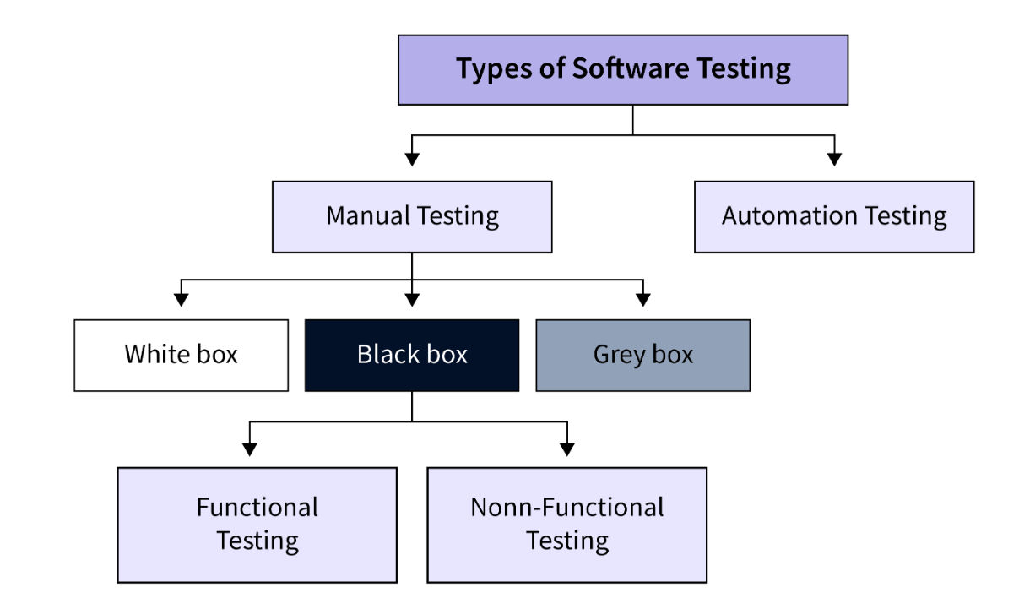

4. Software Testing Methods

Black Box Testing:
This testing is also known as Behavioural Testing. The software tests the internal structural, design, and implementation and UI and UX of the product being tested, which is unknown to the tester. Black box testing is both functional or non-functional, but most of the time, it is usually functional.
This testing technique is named black box because the software or the product is not known or acknowledged in advance to the tester, and hence you can say the tester's eye is blind-folded like a black box, and you can see nothing inside. This technique of testing tries to find errors in these below-mentioned categories:
- Inaccurate or missing functioning of the software.
- Error in the interface.
- Errors in concepts and data structures implementation.
- Database related errors.
- Performance or behavioural errors.
- Errors in starting or termination of a product.

Levels Of Black Box Testing:
This testing technique is related to the below-mentioned software testing methodologies:
- Integration Testing
- System Testing
- Acceptance Testing

White Box Testing:
White Box testing is also termed as Open or transparent-box Testing or Glass-box testing. Sometimes from a developer's point of view, it's known as Code-oriented Testing or structural testing. This type of testing technique deals with testing the internal structure, logic design, and implementation of different modules. Here, the tester uses his / her preferred input or exercises paths via code to determine the proper or exact output. As it is also termed as code-oriented testing, it contains technical tests and script-based testing as part of its testing phase.

Levels of White Box Testing
This testing technique deals with the below-mentioned software testing methodologies:
- Unit Testing: Tests for paths inside a unit and module
- Integration Testing: Tests for paths among different units

5 Software Testing Levels

The two significant levels of software testing are:
- Functional Testing
- Non-functional Testing

Functional Testing:
This is a kind of black box testing that is specification-oriented, which is done by putting the input, and then the output is examined whether it comes the way it is expected. Five steps of testing are there, which involved the testing of an application for functionality. They are:
- Determine the functionality which a projected software is meant to perform.
- Creation of test data depending on the requirements of the application.
- Check for output, depending on the data being tested along with the specifications of your application.
- Scripting of scenarios by testing and then executing those test cases.
- Compare the actual as well as expected output depending on the executed tests.

Non-Functional Testing:
This type of testing deals with testing any product from the requirement point of view that is nonfunctional in type and important at the same time. Nonfunctional testing can be categorized as:
- Performance
- Security
- User interface

6 SDLC (Software Development Life Cycle)

Software Development life cycle (SDLC) is a spiritual model used in project management that defines the stages include in an information system development project, from an initial feasibility study to the maintenance of the completed application.
There are different software development life cycle models specify and design, which are followed during the software development phase. These models are also called "Software Development Process Models." Each process model follows a series of phase unique to its type to ensure success in the step of software development.

Waterfall Model
The waterfall is a universally accepted SDLC model. In this method, the whole proces
s of software development is divided into various phases.

The waterfall model is a continuous software development model in which development is seen as flowing steadily downwards (like a waterfall) through the steps of requirements analysis, design, implementation, testing (validation), integration, and maintenance.

RAD Model
RAD or Rapid Application Development process is an adoption of the waterfall model; it targets developing software in a short period. The RAD model is based on the concept that a better system can be developed in lesser time by using focus groups to gather system requirements.
- Business Modelling
- Data Modelling
- Process Modelling
- Application Generation
- Testing and Turnover

Spiral Model

The spiral model is a risk-driven process model. This SDLC model helps the group to adopt elements of one or more process models like a waterfall, incremental, waterfall, etc. The spiral technique is a combination of rapid prototyping and concurrency in design and development activities.
Each cycle in the spiral begins with the identification of objectives for that cycle, the different alternatives that are possible for achieving the goals, and the constraints that exist. This is the first quadrant of the cycle (upper-left quadrant).
The next step in the cycle is to evaluate these different alternatives based on the objectives and constraints. The focus of evaluation in this step is based on the risk perception for the project.

V-Model
In this type of SDLC model testing and the development, the step is planned in parallel. So, there are verification phases on the side and the validation phase on the other side. V-Model joins by Coding phase.

Agile Model
Agile methodology is a practice which promotes continues interaction of development and testing during the SDLC process of any project. In the Agile method, the entire project is divided into small incremental builds. All of these builds are provided in iterations, and each iteration lasts from one to three weeks.

The core benefit is to control the changes in the software development process. This allows development teams to deliver working software quickly and release updates more frequently. Agile SDLC gives a flexible approach to developing software in a constantly changing environment and according to the customer needs.

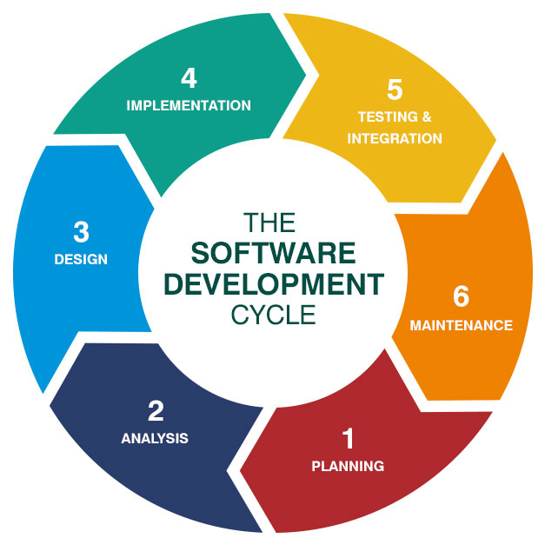

Software testing life cycle contains the following steps:
- Planning
- Analysis
- Design
- Implementation
- Testing
- Maintenance

- The first phase is dedicated to requirement gathering and analysis. All vital information is gathered and analyzed. This step is designed to resolve all ambiguities regarding future software.
- Design is the second phase of the software development life cycle. This is where the entire architecture of the future project is created.
- Coding, which is also called implementation, is the third phase in SDLC. All the components of the designed software are implemented, and the source code is created.
- Testing involves the checking of any faulty parts of the code and their fixes. Everything is thoroughly tested and, if needed, re-tested until all problems are solved.
- Deployment: After the software has been tested and all necessary iterations are made, it enters the deployment phase. The project is then released to end users.
- Maintenance accompanies software along its whole life cycle. If users find any issues, depending on how severe they are, the problem can be hot-fixed or fixed with the next planned release.

7 STLC (Software Testing Life Cycle)
The procedure of software testing is also known as STLC (Software Testing Life Cycle) which includes phases of the testing process. The testing process is executed in a well-planned and systematic manner. All activities are done to improve the quality of the software product.
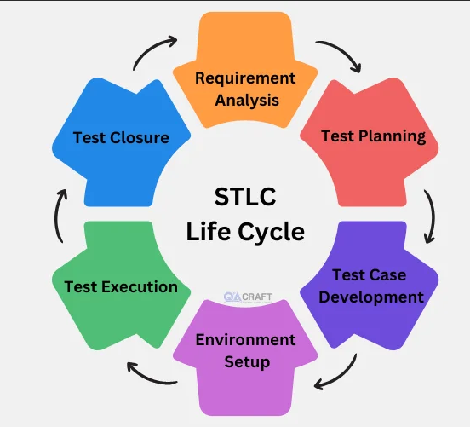
Let's see, the different steps of STLC.
Software testing life cycle contains the following steps:
1.Requirement Analysis
2.Test Plan Creation
3.Environment setup
4.Test case Execution
5.Defect Logging
6.Test Cycle Closure

Requirement Analysis:
The first step of the manual testing procedure is requirement analysis. In this phase, tester analyses requirement document of SDLC (Software Development Life Cycle) to examine requirements stated by the client. After examining the requirements, the tester makes a test plan to check whether the software is meeting the requirements or not.

Test Plan Creation:
Test plan creation is the crucial phase of STLC where all the testing strategies are defined. Tester determines the estimated effort and cost of the entire project. This phase takes place after the successful completion of the Requirement Analysis Phase. Testing strategy and effort estimation documents provided by this phase. Test case execution can be started after the successful completion of Test Plan Creation.

Environment setup:
Setup of the test environment is an independent activity and can be started along with Test Case Development. This is an essential part of the manual testing procedure as without environment testing is not possible. Environment setup requires a group of essential software and hardware to create a test environment. The testing team is not involved in setting up the testing environment, its senior developers who create it.

Test case Execution:
Test case Execution takes place after the successful completion of test planning. In this phase, the testing team starts case development and execution activity. The testing team writes down the detailed test cases, also prepares the test data if required. The prepared test cases are reviewed by peer members of the team or Quality Assurance leader.
RTM (Requirement Traceability Matrix) is also prepared in this phase. Requirement Traceability Matrix is industry level format, used for tracking requirements. Each test case is mapped with the requirement specification. Backward & forward traceability can be done via RTM.

Defect Logging:
Testers and developers evaluate the completion criteria of the software based on test coverage, quality, time consumption, cost, and critical business objectives. This phase determines the characteristics and drawbacks of the software. Test cases and bug reports are analysed in depth to detect the type of defect and its severity.
Defect logging analysis mainly works to find out defect distribution depending upon severity and types. If any defect is detected, then the software is returned to the development team to fix the defect, then the software is re-tested on all aspects of the testing.

Test Cycle Closure:
The test cycle closure report includes all the documentation related to software design, development, testing results, and defect reports.
This phase evaluates the strategy of development, testing procedure, possible defects to use these practices in the future if there is a software with the same specification.
8 Software Testing Documentation

The testing of software is a vital part of the Software Development Life Cycle (SDLC) model. During the testing process, products which need to be developed requires a proper plan and following documentation for better testing and redevelopment. So, most of the company’s focus on producing documentation of their product at the development phase.
Documenting is done in graphic format, defining, identifying, reporting various activities, gathering proper requirements and procedures. Documenting is as crucial as the successful development of the product itself.

Common Documentation Artifacts:
Some commonly applied documentation artifacts associated with software testing are:
- Test Plan
- Test Scenario
- Test Case
- Traceability Matrix
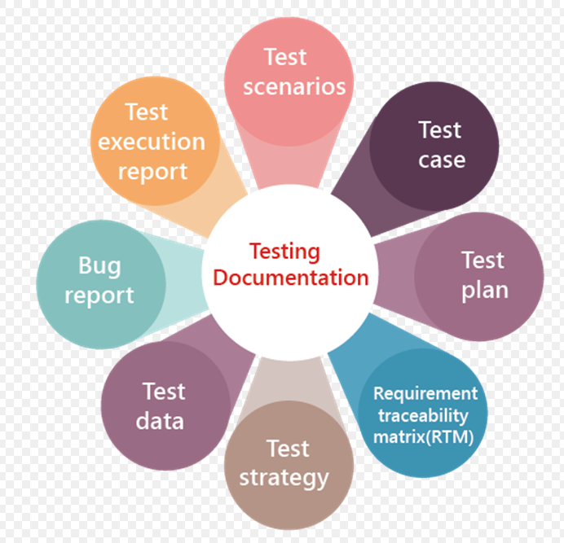
9 Test Plan

Test plans provide the outline strategy which will be implemented for testing the application, and the resources which will be needed are also described; it also holds the details about in under which environment test will be performed.
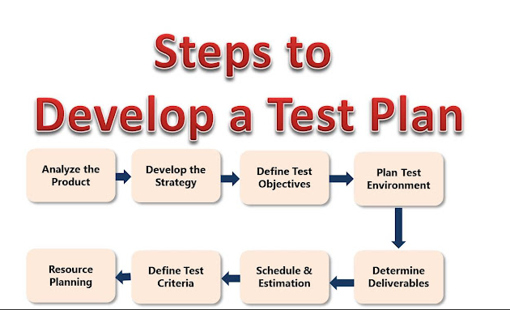

10 Test Scenario

A test scenario can be considered as a single line statement that notifies the area in which your application will experiment. This artifact is needed to ensure the overall procedure is tested from start to finish.

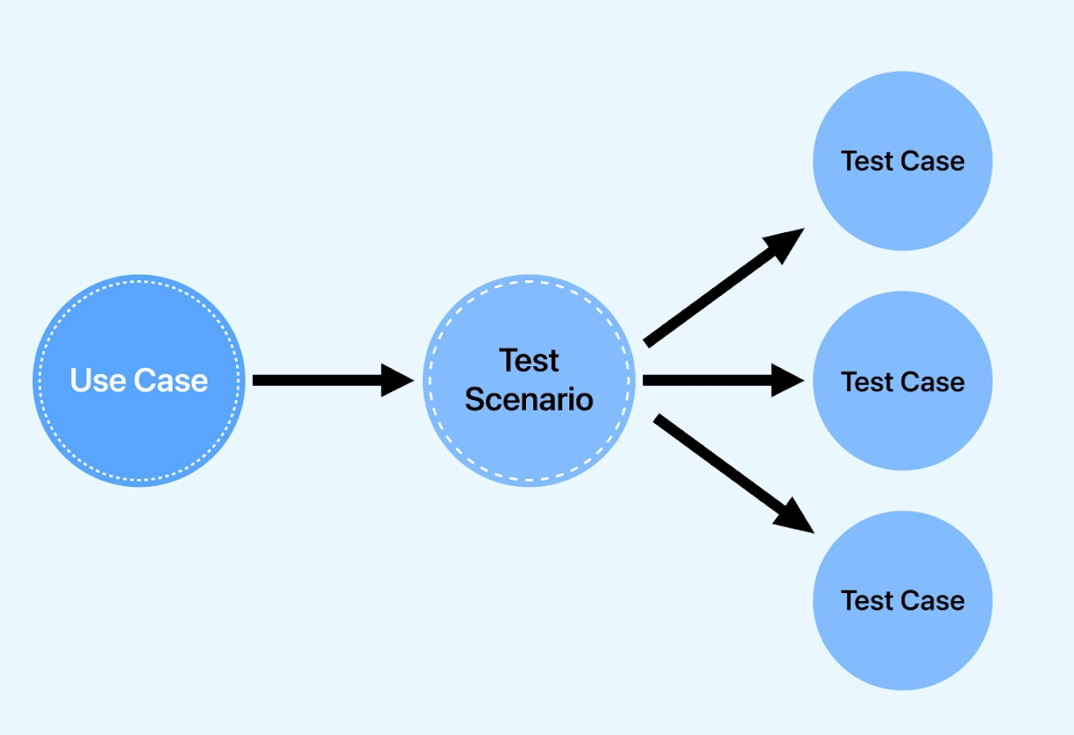

11 Test Case

Test cases engage in collected steps and conditions with inputs that can be implemented at the time of testing. This activity focuses on making sure whether a product went through a set of tests or fails by any means such as functionality or other aspects. Many types of test cases are being checked during testing. These are:
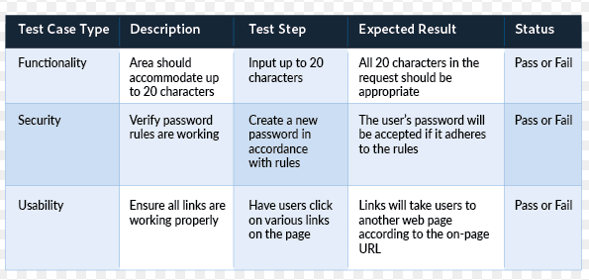

12 Traceability Matrix

It is also known as Requirement Traceability Matrix (RTM), which contains a table that sketches the requirements when your product's SDLC model is being created. This documenting artifact can be implemented for forward tracing, which is to go from designing to coding) or can be implemented for backward tracing as well, which is the reverse of the forward tracing.

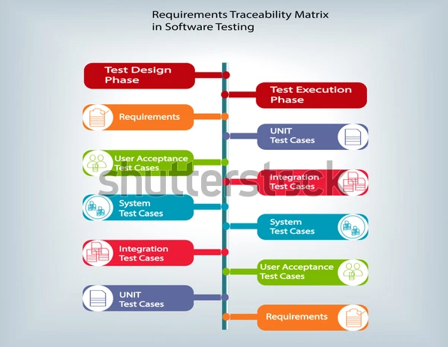

13 Alpha and Beta Testing

Alpha Testing:
Alpha Testing can be defined as a form of acceptance testing carried out to identify various types of issues or bugs before publishing the build or executable of the software public or market. This test type focuses on real users through black box and white box testing techniques.
Alpha testing any product is done when product development is on the verge of completion. Slight changes in design can be made after conducting the alpha test. Alpha testing is done early at the end of software development before beta testing.

Beta Testing:
Beta Testing can be defined as the second stage of testing any product before release, where a sample of the released product with minimum features and characteristics is being given to the intended audience for trying out or temporarily using the product. Unlike an alpha test, the beta test is being carried out by real users in the real environment. This allows the targeted customers to dive into the product's design, working, interface, functionality, etc.

14 Bug Life Cycle

In this section, we will learn about the bug life cycle and the different status of bugs and bug report template.
Here, we will talk about the complete life cycle of a bug from the stage it was found, fixed, re-test, and close.
We have some different status of bugs like new/open, assigned, fix, re-open, and closed.
As soon as the test engineer finds the bug, status is given as New, which indicates that a bug is just found.
This new bug needs to be reported to the concerned Developer by changing the status as Assigned so that the responsible person should take care of the bug.
Then the Developer first go through the bug, which means that the Developers read all the navigation steps to decide whether it is a valid bug or not.
Based on this, if the bug is valid, the Developer starts reproducing the bug on the application, once the bug is successfully reproduced, the Developer will analyse the code and does the necessary changes and change the status as Fixed.
Once the code changes are done, and the bug is fixed, the test engineer re-test the bug, which means that the test engineer performs the same action once again, which is mentioned in the bug report, and changes the status accordingly:
Close, if the bug fixes properly, and functionally working according to the requirement.

Whom to assign the bug
The bug can be assigned to the following:
- Developers
- Developers lead
- Test lead
Developers: If we know who has developed that particular module.
Developer lead: If we don't know the Developer who has developed the particular module.
Test lead: When we don't have any interaction with the development team.
When the bug is fixed and closed or if it is having any impact on the other module, then we go for a new bug report.

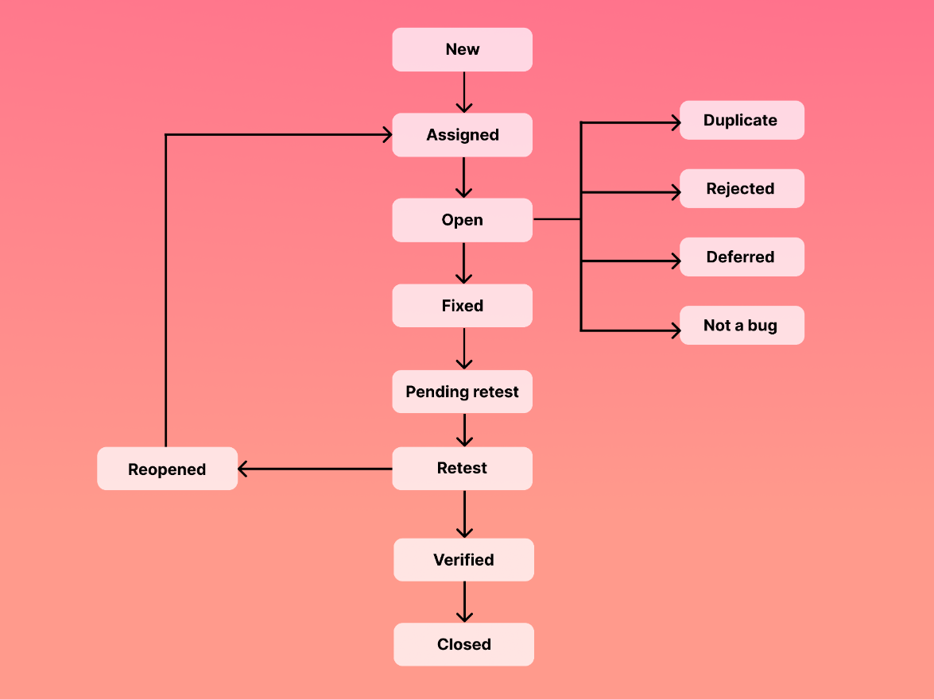

15 Verification and Validation

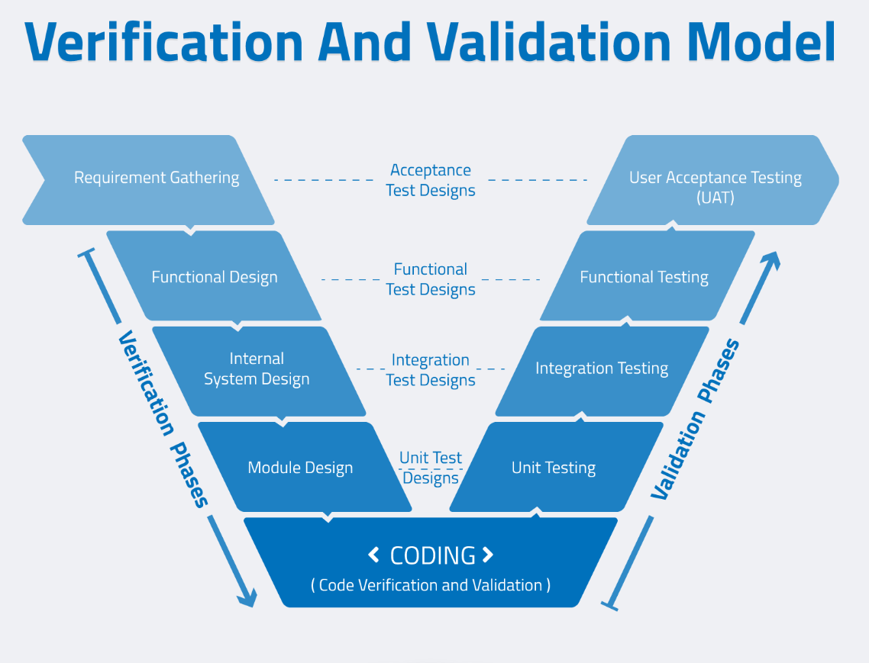

Verification testing
Verification testing includes different activities such as business requirements, system requirements, design review, and code walkthrough while developing a product.
It is also known as static testing, where we are ensuring that "we are developing the right product or not". And it also checks that the developed application fulfilling all the requirements given by the client.

Validation testing
Validation testing is testing where tester performed functional and non-functional testing. Here functional testing includes Unit Testing (UT), Integration Testing (IT) and System Testing (ST), and non-functional testing includes User acceptance testing (UAT).

